Framework Migration

🌟 Definition
# Source: AI Source: Provided by: [Data Path: Persons Table -> ID Column: 1, Name_En Column: Motasem Essam] -> From: [ChatGPT] on [6/7/2026]
Framework Migration is the process of moving an application from one software framework to another framework while keeping the application's core functionality intact.
A framework provides the structure, libraries, and tools used to build an application.

🎯 Purpose
# Source: AI Source: Provided by: [Data Path: Persons Table -> ID Column: 1, Name_En Column: Motasem Essam] -> From: [ChatGPT] on [6/7/2026]
Framework migration is performed to:
- Modernize applications
- Improve performance
- Gain new features
- Improve security
- Receive long-term support
- Reduce technical debt
- Improve developer productivity

🧠 Simple Definition
# Source: AI Source: Provided by: [Data Path: Persons Table -> ID Column: 1, Name_En Column: Motasem Essam] -> From: [ChatGPT] on [6/7/2026]
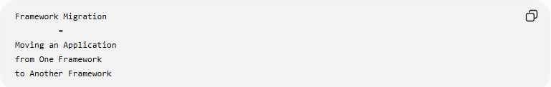
Framework Migration
=
Moving an Application
from One Framework
to Another Framework

📚 What is a Framework?
# Source: AI Source: Provided by: [Data Path: Persons Table -> ID Column: 1, Name_En Column: Motasem Essam] -> From: [ChatGPT] on [6/7/2026]
A framework is a collection of tools, libraries, and conventions that help developers build applications.
Examples:
PHP Frameworks
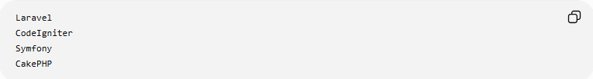
Laravel
CodeIgniter
Symfony
CakePHP

JavaScript Frameworks
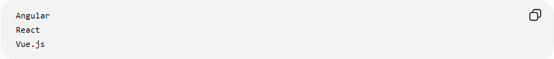
Angular
React
Vue.js

Python Frameworks
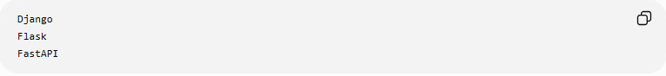
Django
Flask
FastAPI

.NET Frameworks
ASP.NET MVC
ASP.NET Core

🔍 Common Framework Migration Examples

1️⃣ PHP Framework Migration
# Source: AI Source: Provided by: [Data Path: Persons Table -> ID Column: 1, Name_En Column: Motasem Essam] -> From: [ChatGPT] on [6/7/2026]
Before
CodeIgniter
↓
After
Laravel

Reasons:
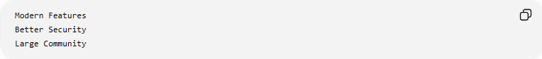
Modern Features
Better Security
Large Community

2️⃣ JavaScript Framework Migration
# Source: AI Source: Provided by: [Data Path: Persons Table -> ID Column: 1, Name_En Column: Motasem Essam] -> From: [ChatGPT] on [6/7/2026]
Before
AngularJS
↓
After
Angular

or
AngularJS
↓
React

Reasons:
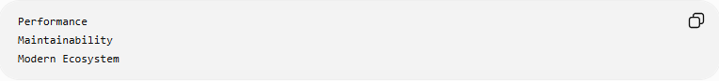
Performance
Maintainability
Modern Ecosystem

3️⃣ Python Framework Migration
# Source: AI Source: Provided by: [Data Path: Persons Table -> ID Column: 1, Name_En Column: Motasem Essam] -> From: [ChatGPT] on [6/7/2026]
Before
Flask
↓
Django

Reasons:
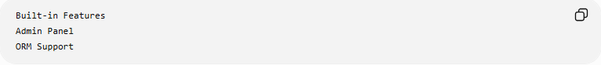
Built-in Features
Admin Panel
ORM Support

4️⃣ .NET Framework Migration
# Source: AI Source: Provided by: [Data Path: Persons Table -> ID Column: 1, Name_En Column: Motasem Essam] -> From: [ChatGPT] on [6/7/2026]
Before
ASP.NET Framework
↓
ASP.NET Core

Benefits:
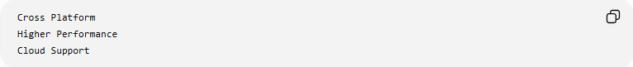
Cross Platform
Higher Performance
Cloud Support

🛠️ Real-World Example
# Source: AI Source: Provided by: [Data Path: Persons Table -> ID Column: 1, Name_En Column: Motasem Essam] -> From: [ChatGPT] on [6/7/2026]
Before Migration
An old PHP application:
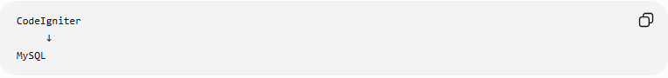
CodeIgniter
↓
MySQL
Problems:
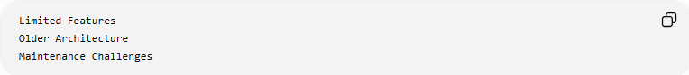
Limited Features
Older Architecture
Maintenance Challenges

Migration
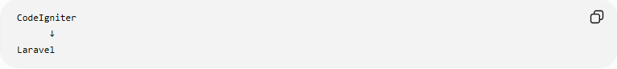
CodeIgniter
↓
Laravel

After Migration
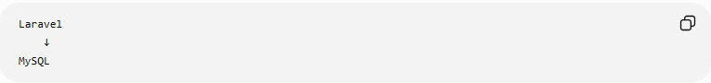
Laravel
↓
MySQL
Benefits:
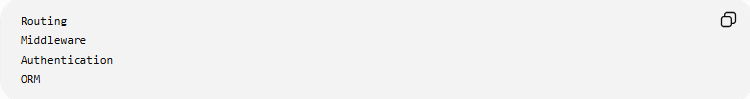
Routing
Middleware
Authentication
ORM

🔄 Framework Migration Lifecycle
# Source: AI Source: Provided by: [Data Path: Persons Table -> ID Column: 1, Name_En Column: Motasem Essam] -> From: [ChatGPT] on [6/7/2026]
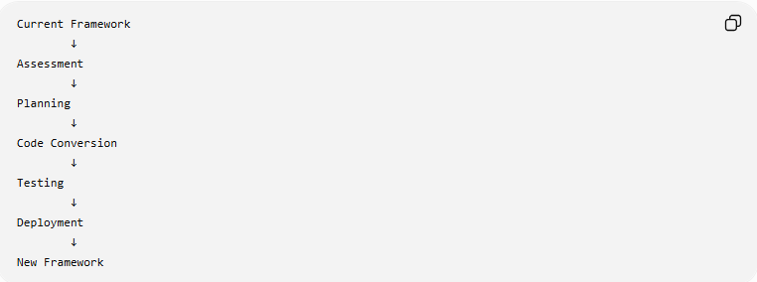
Current Framework
↓
Assessment
↓
Planning
↓
Code Conversion
↓
Testing
↓
Deployment
↓
New Framework

📦 What Usually Changes?
# Source: AI Source: Provided by: [Data Path: Persons Table -> ID Column: 1, Name_En Column: Motasem Essam] -> From: [ChatGPT] on [6/7/2026]
Routing
Before
Old Routing System

After
New Routing System

Database Access
Before
Custom SQL Queries

After
ORM
Query Builder

Authentication
Before
Custom Login System

After
Built-In Authentication

Project Structure
Before
Old Folder Layout

After
Framework Standard Structure

🌍 Example: AngularJS → Angular
# Source: AI Source: Provided by: [Data Path: Persons Table -> ID Column: 1, Name_En Column: Motasem Essam] -> From: [ChatGPT] on [6/7/2026]
Before
AngularJS 1.x
Characteristics:
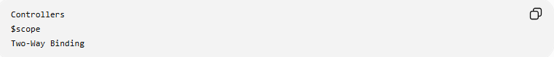
Controllers
$scope
Two-Way Binding

After
Angular
Characteristics:
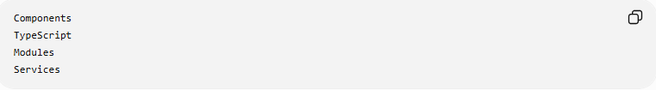
Components
TypeScript
Modules
Services

Migration may require:
Rewriting Components
Updating Services
Changing Architecture

⚠️ Common Challenges
# Source: AI Source: Provided by: [Data Path: Persons Table -> ID Column: 1, Name_En Column: Motasem Essam] -> From: [ChatGPT] on [6/7/2026]
Code Rewriting
Frameworks often use different architectures.

Learning Curve
Developers must learn:
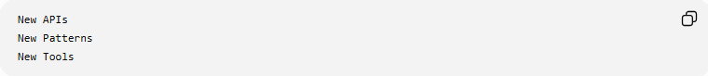
New APIs
New Patterns
New Tools

Third-Party Packages
Some packages may not be available in the new framework.

Testing Effort
The entire application must be retested.

Time and Cost
Large projects can take months to migrate.

✅ Benefits
# Source: AI Source: Provided by: [Data Path: Persons Table -> ID Column: 1, Name_En Column: Motasem Essam] -> From: [ChatGPT] on [6/7/2026]
Better Performance
Faster Execution
Lower Resource Usage

Improved Security
Modern frameworks include:
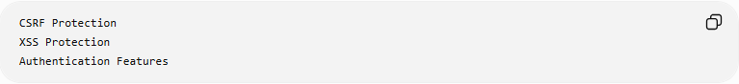
CSRF Protection
XSS Protection
Authentication Features

Long-Term Support
Bug Fixes
Security Updates

Developer Productivity
Built-in features reduce development time.

Modern Ecosystem
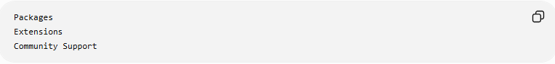
Packages
Extensions
Community Support

📊 Framework Migration vs Platform Migration
# Source: AI Source: Provided by: [Data Path: Persons Table -> ID Column: 1, Name_En Column: Motasem Essam] -> From: [ChatGPT] on [6/7/2026]
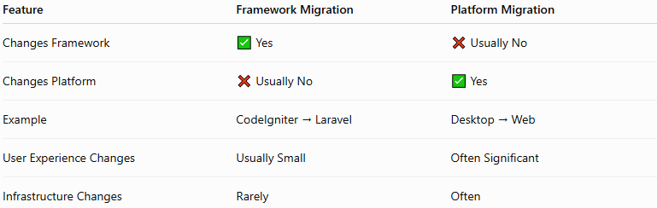
Feature | Framework Migration | Platform Migration
Changes Framework | ✅ Yes | ❌ Usually No
Changes Platform | ❌ Usually No | ✅ Yes
Example | CodeIgniter → Laravel | Desktop → Web
User Experience Changes | Usually Small | Often Significant
Infrastructure Changes | Rarely | Often

Framework Migration Example
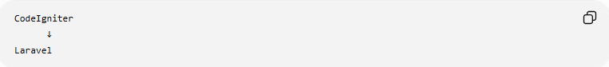
CodeIgniter
↓
Laravel
Still a PHP web application.

Platform Migration Example
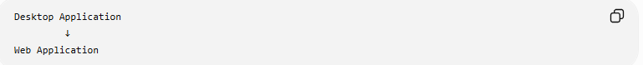
Desktop Application
↓
Web Application
Changes the entire platform.

🛠️ Common Framework Migration Tools
# Source: AI Source: Provided by: [Data Path: Persons Table -> ID Column: 1, Name_En Column: Motasem Essam] -> From: [ChatGPT] on [6/7/2026]
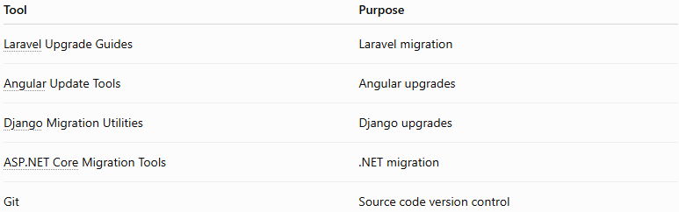
Tool | Purpose
Laravel Upgrade Guides | Laravel migration
Angular Update Tools | Angular upgrades
Django Migration Utilities | Django upgrades
ASP.NET Core Migration Tools | .NET migration
Git | Source code version control

🧠 Simple Analogy
# Source: AI Source: Provided by: [Data Path: Persons Table -> ID Column: 1, Name_En Column: Motasem Essam] -> From: [ChatGPT] on [6/7/2026]
Imagine building a house.
Before
Old Construction Toolkit

Migration
Replace Tools
Learn New Methods

After
Modern Construction Toolkit
The house serves the same purpose, but it is built and maintained using better tools.
Framework migration works similarly:
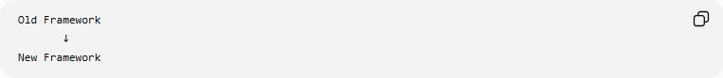
Old Framework
↓
New Framework
while keeping the application's main functionality intact.

🧭 Summary
# Source: AI Source: Provided by: [Data Path: Persons Table -> ID Column: 1, Name_En Column: Motasem Essam] -> From: [ChatGPT] on [6/7/2026]
Framework Migration is a type of application migration where software is moved from one development framework to another, such as CodeIgniter → Laravel, AngularJS → Angular, Flask → Django, or ASP.NET Framework → ASP.NET Core. It focuses on modernizing the application's codebase, improving performance, security, maintainability, and long-term support while preserving the application's core business functionality.

